LS2: Company Business - Recruiting

Recruitment

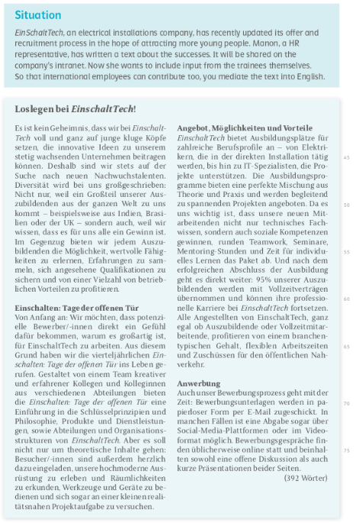
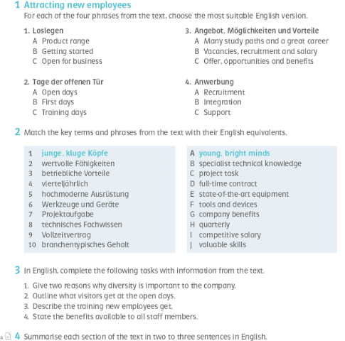

Now write a complete mediation of the text.

Task: Find the correct version of the mediation.

Getting Started at Einschalt Tech

a) We want, that potential candidates directly get a feeling why it is big to work for Einschalt Tech. That’s why we invented the quarterly Open Door Days. Visitors are invited to serve the modern tools and to try a little real near project task.

b) Einschalt Tech strongly relies on young talents who contribute fresh ideas to the company’s continuous growth. Diversity is key, as many trainees come from all over the world, bringing valuable perspectives. In return, the company offers extensive learning opportunities, recognized qualifications, and a wide range of benefits.

c)
Einschalt Tech is totally concentrated on young clever minds, but only from Germany. Diversity doesn’t really play a role. The company pays very high salaries instead of offering learning opportunities.

Einschalten: Open House Days

a) We want, that potential candidates directly get a feeling why it is big to work for Einschalt Tech. That’s why we invented the quarterly Open Door Days. Visitors are invited to serve the modern tools and to try a little real near project task.

b) To give applicants a real feel for the company, Einschalt Tech hosts quarterly Open House Days. These events showcase the company’s philosophy, products, and departments while also providing hands-on experiences. Visitors are encouraged to explore facilities, try out equipment, and even take part in small, realistic project tasks.

Opportunities and Benefits
The company offers a variety of training programs in both technical and IT fields, combining theory with practical experience. Beyond technical skills, trainees also develop social competencies through teamwork, seminars, and mentoring. After graduation, 95% of trainees receive a full-time contract, along with benefits like flexible hours, fair pay, and public transport subsidies.

Recruitment
The application process at Einschalt Tech is modern and completely paperless. Applications can be submitted via email, social media platforms, or even in video format. Interviews are usually held online and include open discussions as well as short presentations from both sides.

